Malachi - Confronting Spiritual Complacency

Timeline
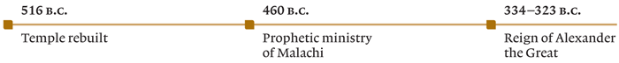
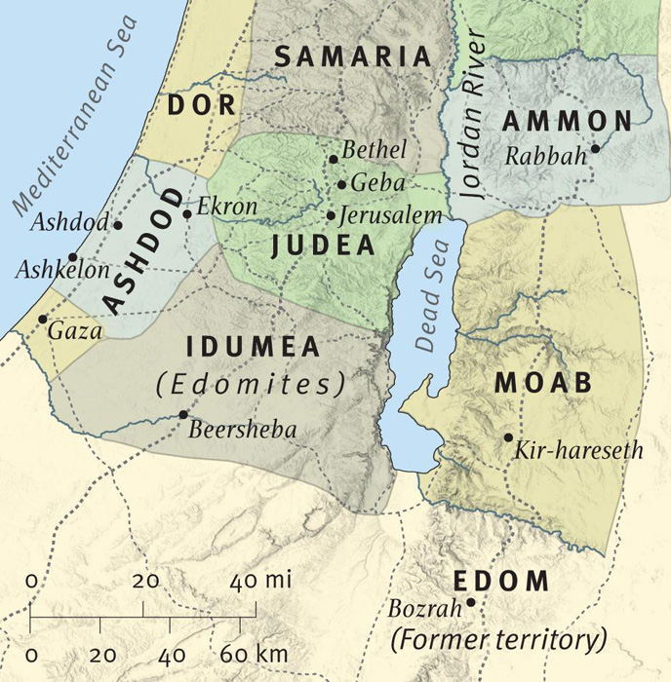
From - www.esv.org/resources/esv-global-study-bible/introduction-to-malachi/
1. Malachi 1:1-5 Does God love me?
Ice Breaker
Have you ever doubted the love someone has for you? That is, say a parent, sibling or friend?

What evidence may have affirmed your confidence in their attitude to you?

Bible Reading Read Malachi 1:1-5

1. The prophet identifies himself as Malachi (v1), which in Hebrew means “my messenger”. This may have been a pseudonym (i.e. a title). If so , why?

2. In what way are we to be messengers? Consider Isaiah 52:7, 2 Corinthians 5:17-21.

3. In his first message (v2), the prophet speaks to the theme of being loved and knowing you are loved. Why would this be important?

4. What is the contrast that Malachi points to in verses 2-4, that demonstrates God’s love?

5. Malachi states that God’s dealing with people and nations are because of His choice. Is this how He deals with people generally? Read also Romans 9:10-13 and Genesis 25:19-26.

6. God is the lord of time. How much do you think foreknowledge may influence God’s choices? Read Hebrews 12:15-17, Genesis 25:27-34.

7. The descendants of the two brothers were often in conflict. Describe the events of Numbers 20:14-21.

8. In the years following the time of Malachi, the Nabateans (tribes from Arabia) decimated Edom. Read Jeremiah 49:17-18. What comparison is made?

9. Edom was a picture of what Israel could have been if they were not under God’s leadership. Reflecting upon your life’s journey, how would you describe what your life would have been, if you were not following Christ?

10. Some would say that the nations that have sought to honour God have been more successful than other nations. Do you think that is true? What would be some examples?

2. Malachi 1:6:14 Who Gets Your Best?

Ice Breaker

Have you ever purchased food from a shop or supermarket and taken it home to find it was off?

How did you feel?

Bible Reading Read Malachi 1:6-14

1. This passage is about worship. The word worship is derived from the old English word “worth-ship” and means to attribute worth.
Read the requirements for animal selection for sacrifice in Leviticus 22:17-22. Why would these be important?

2. By offering defiled food and sacrificing lame or diseased animals (v 7-8), what were the people saying?

3. Christians don’t do animal sacrifices today. What do we do for worship instead?

4. What would be deficient worship from a Christian?

5. Have a look at the following passages. What type of deficient worship could they indicate?
Romans 12:1-2

John 13:34-35 & 1 John 4:20-21

Matthew 5:23-24

Luke 18:9-14

Rev 3:14-22

6. Can you think of other passages in the New Testament that may be relevant to Christians?

7. Pure worship makes God’s name great among the nations (v11) . How can we do the same?

8. People found their worship to be tiresome or a burden (boring ?) (v13). In today’s entertainment saturated culture what may be the indications of the same attitude?

9. The cheat vows to give the best but then gives the worst (v14). In what ways can we be two faced in what we do?

3. Malachi 2:1-9. Lethargic leadership

Ice Breaker

Have you ever suffered from the results of the bad or poor leadership of others? That is, people who were supposed to be leaders, say a boss, Politian, principal, minister or elder etc.

Bible Reading Read Malachi 2:1-9

1. What curse could come upon leaders who do not listen to God ? (v 1-2)

2. “Because of you, I will rebuke your descendants”(v3) What would this mean?
Read Luke 11:47-51

3. Levi was the name of the tribe that became the priests among the people and here is personified as the Godly leader. (v4-7) Which Bible character would fit all the attributes mentioned?

4. From these verses (v4-7) List the attributes of good leadership.

5. The Bible teaches us, that all believers are priests (Rev 1:5-6, 1 Peter 2:5,9) Which of the above attributes would you identify as important for a Christian to demonstrate?

6. Malachi then identifies where the current leadership was failing. List the faults he identifies in v 8-9.

7. Sometimes churches suffer from bad leadership. What problems do you see today are similar to the problems of Malachi’s time?

8. Bad leaders were caused to be despised and humiliated (v9). Does this still happen today?
What are some examples.

4. Malachi 2:10:16 For better or worse

Ice Breaker

Have you or someone close to you been affected by divorce?

How would you describe the effect it has had on the people you know?

Bible Reading Read Malachi 2:10-16

1. Compare v10 with John 17:20-21 & 1 Corinthians 12:12-13. Why is “oneness” so important?

2. What is the problem of marrying a woman who worships a foreign god? (v11)

3. Solomon was king of Israel during its golden era. What was the cause of his downfall?
1 Kings 11:1-8

4. What is Paul’s advice in 2 Corinthians 6:14-18 ?

5. Some people commit wrong and then hope to make up for it (v12), is this always possible? Consider also 1 Samuel 15:20-23.

6. What problem does Malachi address in v13-15?

7. On addressing unfaithfulness Malachi twice uses the expression “wife of your youth” rather than just “wife” (v14 & 15). In using this expression, what was Malachi implying was the underlying motivation of the people, for the unfaithfulness that leads to divorce?

8. In Bible times women had little economic and social power in comparison to their husbands. The inheritance was passed on to sons only (unless no sons were alive, Num 27:1-11), education was for the boys and men, men had the full range of employment opportunities, voting rights and legal rights. In a world of no pensions or unemployment benefits, a divorced woman would find herself in great difficulty.

Read verse 16 in a few different translations. What do you pick up on God’s feelings about divorce? Why would God feel this way?

9. Read Matthew 19:3-9. How would you summarise what Jesus teaches on the matter?

10. Compare vs 13-14 with 1 Peter 3:7. What concept about prayer is being taught?

10. We are not under law but grace. Sometimes someone may find themselves married to a crackpot (or worse). Are there any circumstances where divorce and remarriage may be ok?

5. Malachi 2:17-3:5 Return while there is still time

Ice Breaker

Has anyone wearied you by the repetition of their words and ideas that you find obnoxious?

Do you think we sometimes weary God in this way? If so, how?

Bible Reading Read Malachi 2:17- 3:5

1. The band Moving Pictures, sing “What about me, it isn’t fair, I’ve had enough, now I want my share” What do you see as the evidence for dissatisfaction in our society (2:17)?

2. Who is the messenger spoken of in verse 3:1 and what was his purpose? Read Matthew 11:7-11

3. “Suddenly the Lord you are seeking will come to his temple” (3:1). Read John 2:13-17.
What events happened?

4. Read Mark 11:17. What two sins were the people doing with regard to the temple?

5. The implication is that the Lord people are seeking may be quite different to the Lord who turns up, (whip in hand).
How relevant is that to a culture that has replaced God with Santa Claus and keeps Jesus as child in a manger all meek and mild?

6. You are a temple of the Holy Spirit (1 Corinthians 6:19). If God was to suddenly appear and come to your temple, what things may He say?

7. What do you understand of the process of refining (v3) of say gold or silver?

8. How might this process work in the life of the believer? Read James 1:2-5

9. People were breaking covenant in many different ways. Read v5 and list them below.

10. Which of these are still relevant today?

6. Malachi 3:6-12 Robbing God

Ice Breaker

Have you ever been robbed? How did that make you feel?

Bible Reading Read Malachi 3:6-12

1. Have you ever been associated with someone (say family, friend, workmate, church person) who was changeable? How did that affect your relationship with them?

2. What evidence is provided of the unchanging nature of God? (v6)

3. “If God seems far away guess who moved”. What does Malachi say is the root cause of the people’s problems? (v7)

4. Malachi points to tithing . What does the word “tithe” mean?

5. What was the tithe used for? Read Numbers 18:21-24, Deut 14;22-29.

6. Tithing involves choosing to live on the 90% rather than the 100% of our income. What character traits are involved in making that choice?

7. The Christian, although not under the law, is still encouraged to give. From the following passages, what are we to do with our money? 1 Cor 9:13-14, 1 Cor 16:1-3, Luke 12:32-34, Philippians 4:14-19

8. Malachi says the people are “robbing” God (v8). Why would he use that expression?

8. Read Matthew 25:24-30. In the parable of the talents, what does the master expect of his slave and why?

9. Compare Deuteronomy 30:15-20 with Malachi 3:9-12. What are the two choices and their consequences, put before the people?

7. Malachi 3:13-4:6 Are you ready to meet Him?

Ice Breaker

Have you ever been unprepared for an event, such as an exam or a function?

Bible Reading Read Malachi 3:13-4:6

1. What would you say to those who say it is a waste of time and futile to serve God? (v14)

2. In your experience, are the detractors partly right or have a point?
Are the arrogant sometimes seemingly blessed?
Do evildoers seem to prosper?
Do some who test God get away with it?

3. Some people believe in God, because they cannot imagine a world where the most evil people in the world such as Adolf Hitler, seemingly have died without being held accountable for their sin. What do you think?

4. Read 3:16-18. What is the purpose of the “scroll of remembrance”(v16)? Read also Daniel 12:1-3, Rev 20:11-15.

5. “Surely the day is coming”(4:1) The “day” is mentioned four times in 3:17 to 4:3.
What are the things that will occur on this “day”

6. To what event do you think this day is referring to? For example; the coming of Jesus, or the destruction of Jerusalem in 70AD, the end times, or several different events.

7. What is the promise given in 4:2 for those who revere God’s name? What is the idea it conveys?

8. Malachi concludes with reference to the law and the prophets, personified through Moses (4:4) and Elijah (4:5). Read Matthew 3:1-12. What themes from Malachi do you see in the message of John the Baptist?

